the Australian school band & orchestra festival  music info cover sheet  Held annually through july, august & september | 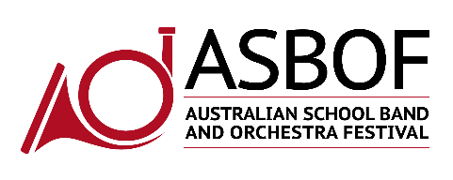  A non-competitive, inspirational  and educational event

NO MUSIC WILL BE ACCEPTED AT THE INFO DESK WITHOUT THIS COVER SHEET

PRIMARY SCHOOLS
Ensemble Name
Music Director
Please indicate with an (X) in which event your ensemble is playing
 | The Wilbur Sampson |  |  |  |  | The Graeme Bell Novice Big Band
 | The Robert McAnally |  |  |  |  | The Ed Wilson Open Big Band
 | The Joe Cook |  |  |  |  | The Nigel Butterly Event
 | The William Lovelock |  |  |  |  | The Dulcie Holland Even
 | The Alex Lithgow Premier Event |  |  |  |  | The Brett Dean Premier Event
 |  |  |  |  |  | The Elena Kats-Chernin Orchestra Event
Event Date
Musical Information
Title of Music
Composer
Arranger
Australian Composition |  |  |  | Yes |  |  |  | No
If you are playing more than one piece, please indicate which order they will be played to ensure the adjudicator has adequate time to prepare for your performance. (e.g. 2 of 3) |  |  |  |  |  |  | This piece will be performed as
 |  |  |  |  |  |  |  |  | Of
Please ensure your score has all the bars numbered

- Deliver your scores on the day to the Information Desk in the Foyer.
- Ensure you submit your scores at the time your ensemble has been scheduled to arrive at the venue.
- Please ensure you deliver the scores with sufficient time for the Adjudicator to study them so that you might receive informed and useful adjudication comments. The earlier the better!
- If your band is playing in the ALEX LITHGOW EVENT you must submit TWO copies as we will have two adjudicators for these Premier Events.

Temporary Copy for Use By an Adjudicator
(APRA/AMCOS Form No 2 Certification Notice)

- Schools entering students into this event acknowledge that their school is covered by three blanket licences:
  - APRA Schools’ Licence: Public Performance of copyright music
  - AMCOS Schools’ Licence: Photocopying and reproduction of copyright music
  - APRA/AMCOS/ARIA Schools’ Licence: Music recordings and access
- These licences are administered through a school’s peak governing body.
- For information on whether your school is currently licensed please contact: print@apra.com.au
- Under the photocopying licence schools are able to make a limited number of photocopies per original score that they own. All copies made for adjudicators are required to be submitted with the official ASBOF Music Info Cover Sheet which confirms that the school named on this form certifies the copy has been made from their own published edition of the musical work, in reliance of Clauses 10.8 and 18 of APRA/AMCOS “A Practical Copyright Guide to the Use of Print Music in Australia” Third Edition, 2006.
- The photocopy will be destroyed by the ASBOF at the conclusion of the performance.

